A6-1 HOP

6.1 Box 1 & 2

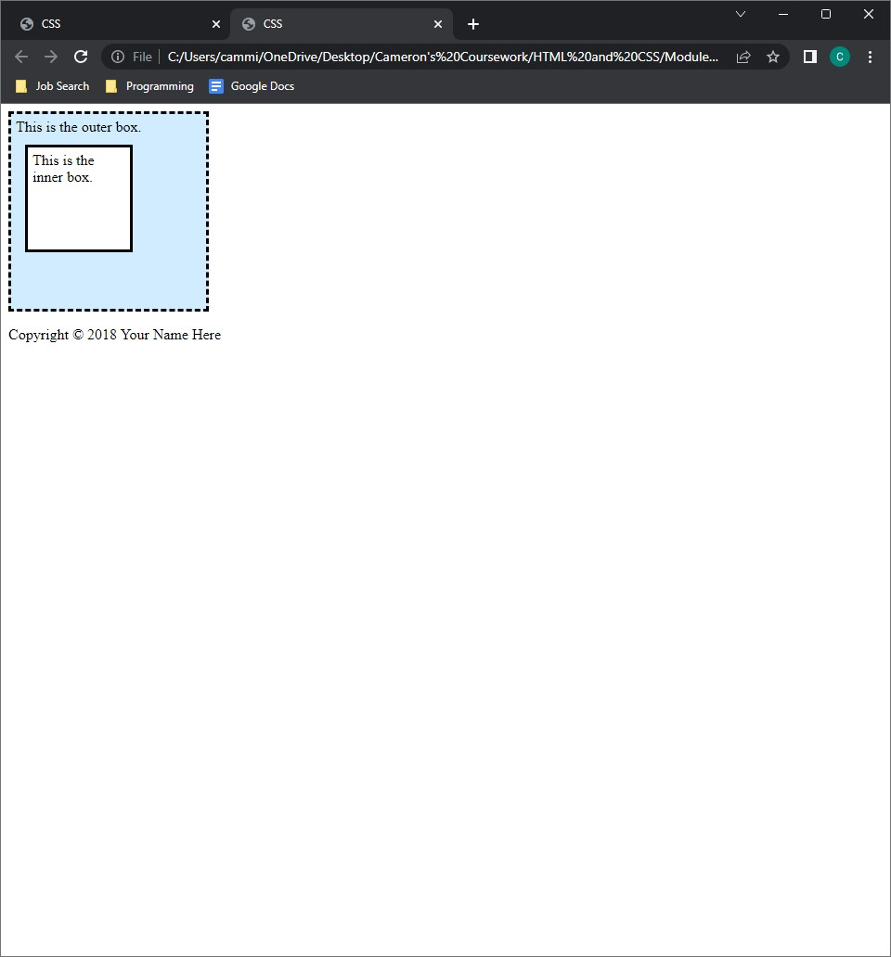

6.2

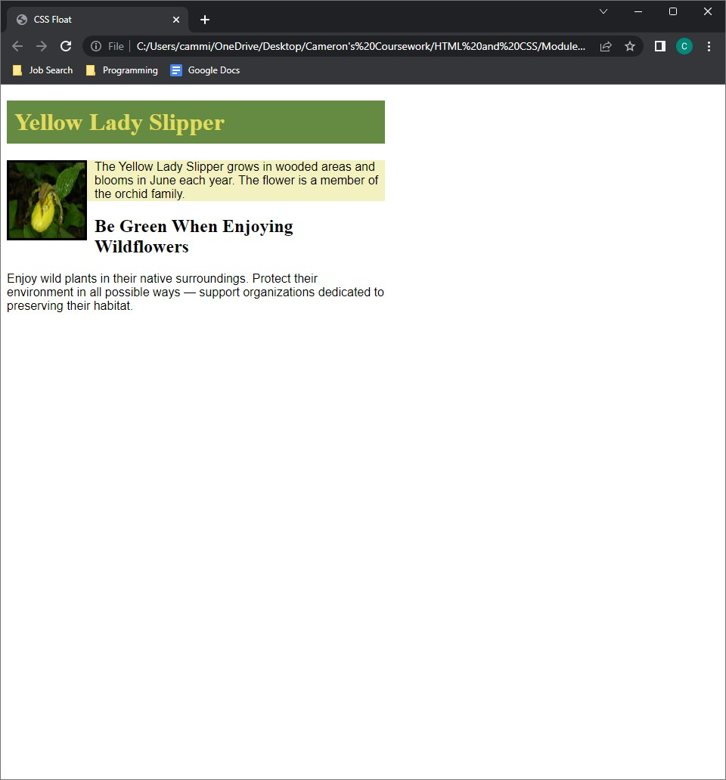

6.3

6.4

6.5

6.6

6.7

6.8

6.9

6.10

